1. Implement simple ESS and with transmitting nodes in wire-less LAN by simulation and determine the performance with respect to transmission of packets.

# Create a NS simulator object

set ns [new Simulator]

#setup trace support by opening file lab4.tr and call the procedure trace-all

set tf [open lab4.tr w]

$ns trace-all $tf

#create a topology object that keeps track of movements of mobile nodes #within the topological boundary.

set topo [new Topography]

$topo load_flatgrid 1000 1000

set nf [open lab4.nam w]

$ns namtrace-all-wireless $nf 1000 1000

# creating a wireless node you MUST first select (configure) the node #configuration parameters to "become" a wireless node.

$ns node-config -adhocRouting DSDV \

-llType LL \

-macType Mac/802_11 \

-ifqType Queue/DropTail \

-ifqLen 50 \

-phyType Phy/WirelessPhy \

-channelType Channel/WirelessChannel \

-propType Propagation/TwoRayGround \

-antType Antenna/OmniAntenna \

-topoInstance $topo \

-agentTrace ON \

-routerTrace ON

# Create god object

create-god 3

set n0 [$ns node]

set n1 [$ns node]

set n2 [$ns node]

$n0 label "tcp0"

$n1 label "sink1/tcp1"

$n2 label "sink2"

$n0 set X_ 50

$n0 set Y_ 50

$n0 set Z_ 0

$n1 set X_ 100

$n1 set Y_ 100

$n1 set Z_ 0

$n2 set X_ 600

$n2 set Y_ 600

$n2 set Z_ 0

$ns at 0.1 "$n0 setdest 50 50 15"

$ns at 0.1 "$n1 setdest 100 100 25"

$ns at 0.1 "$n2 setdest 600 600 25"

set tcp0 [new Agent/TCP]

$ns attach-agent $n0 $tcp0

set ftp0 [new Application/FTP]

$ftp0 attach-agent $tcp0

set sink1 [new Agent/TCPSink]

$ns attach-agent $n1 $sink1

$ns connect $tcp0 $sink1

set tcp1 [new Agent/TCP]

$ns attach-agent $n1 $tcp1

set ftp1 [new Application/FTP]

$ftp1 attach-agent $tcp1

set sink2 [new Agent/TCPSink]

$ns attach-agent $n2 $sink2

$ns connect $tcp1 $sink2

$ns at 5 "$ftp0 start"

$ns at 5 "$ftp1 start"

$ns at 100 "$n1 setdest 550 550 15"

$ns at 190 "$n1 setdest 70 70 15"

proc finish { } {

global ns nf tf

$ns flush-trace

exec nam lab4.nam &

close $tf

exit 0

}

$ns at 250 "finish"

$ns run

**AWK**

BEGIN{

count1=0

count2=0

pack1=0

pack2=0

time1=0

time2=0

}

{

if($1 == "r" && $3 == "_1_" && $4 == "AGT")

{

count1++

pack1=pack1+$8

time1=$2

}

if($1 == "r" && $3 == "_2_" && $4 =="AGT")

{

count2++

pack2=pack2+$8

time2=$2

}

}

END{

printf("The Throughput from n0 to n1: %f Mbps \n", ((count1*pack1*8)/(time1*1000000)));

printf("The Throughput from n1 to n2: %f Mbps \n", ((count2*pack2*8)/(time2*1000000)));

}

Topology:

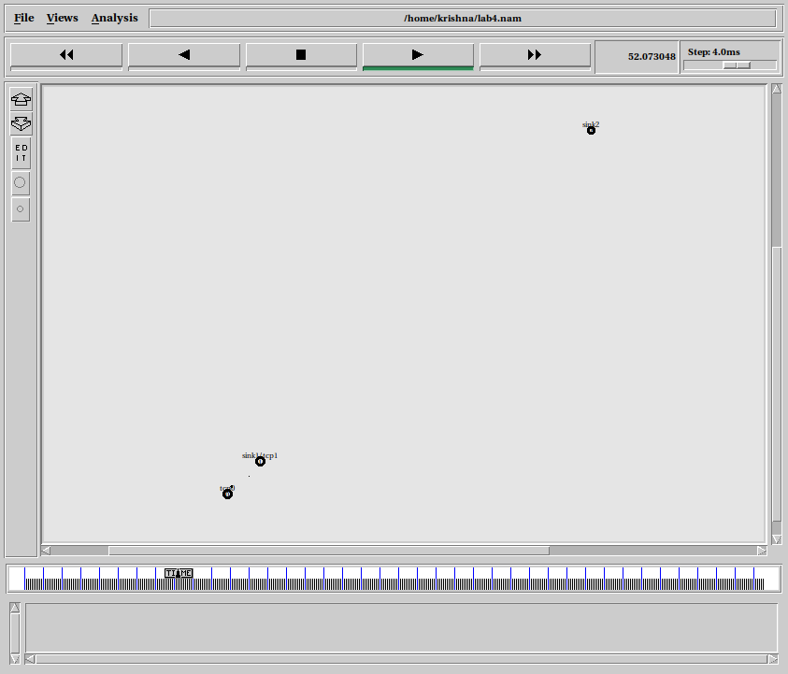

Topology:

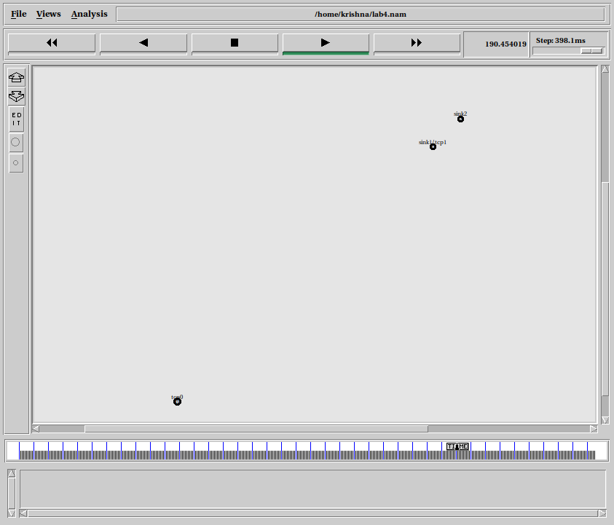

Output:

